1. **设计表**

USE `tourpal`;

DROP TABLE IF EXISTS `user_info`;

CREATE TABLE `user_info` (

`user_number` varchar(50) NOT NULL,

`user_name` varchar(50) DEFAULT NULL,

`user_pw` varchar(50) DEFAULT NULL,

`user_type` varchar(10) DEFAULT NULL,

PRIMARY KEY (`user_number`)

) ENGINE=InnoDB DEFAULT CHARSET=utf8;

1. **DAO层—接口**

导入实体类UserInfo

public interface UserInfoMapper {

UserInfo selectByPrimaryKey(String userNumber);

}

1. **DAO层—实现**

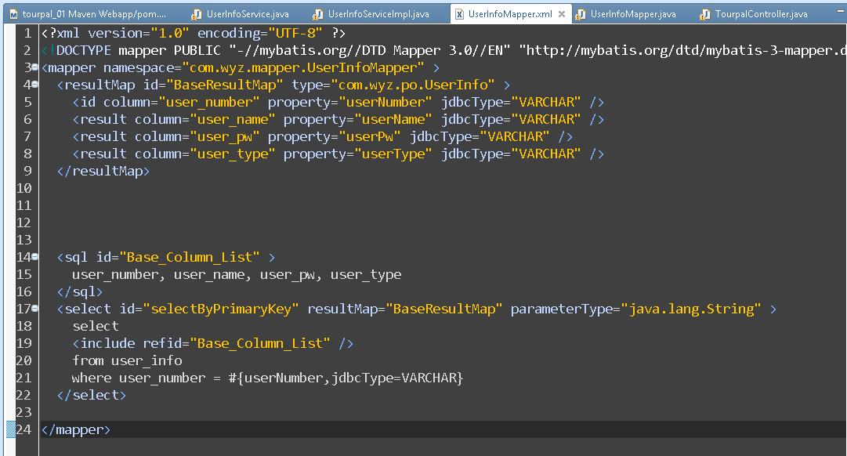

<sql id="Base_Column_List" >

user_number, user_name, user_pw, user_type

</sql>

<select id="selectByPrimaryKey" resultMap="BaseResultMap" parameterType="java.lang.String" >

select

<include refid="Base_Column_List" />

from user_info

where user_number = #{userNumber,jdbcType=VARCHAR}

</select>

1. **业务层—接口**

导入实体类UserInfo

public interface UserInfoService {

public UserInfo getUser(String userNumber);

}

1. **业务层—实现**

导入实体类UserInfo

导入业务层接口

导入DAO层接口

@Service

public class UserInfoServiceImpl implements UserInfoService {

@Resource(name = "userInfoMapper")

private UserInfoMapper userInfoMapper;

public UserInfo getUser(String userNumber) {

System.out.println("业务逻辑层：" + userNumber);

return userInfoMapper.selectByPrimaryKey(userNumber);

}

}

1. **控制器—登录验证**

导入实体UserInfo

导入业务层—接口

@RequestMapping("login.do")

public String login(String userNumber, String userPw, Model model,

HttpSession session) {

if (userNumber != null && !userNumber.equals("")) {

// 创建一个实体类定义

UserInfo user = userService.getUser(userNumber);

if (user != null && user.getUserPw().equals(userPw)) {

session.setAttribute("userinfo", user);

//return query(model);

return "welcome";

} else {

model.addAttribute("info", "账号或密码错误");

}

} else {

model.addAttribute("info", "账号密码不能为空");

}

return "login";

}

1. **视图层**

<div data-role="content">

<form action="<%=basePath %>tourpal/login.do" method="post" style="padding: 10px 20px;">

<h3 align="center">

<img alt="" src="<%=basePath %>resources/tourpal/img/logo.png" height="200px">

</h3>

<div align="center" style="color: red;">${info }</div>

<label for="un" class="ui-hidden-accessible">账号:</label> <input

type="text" name="userNumber" id="un" placeholder="请输入账号" /> <label

for="un2" class="ui-hidden-accessible">密码:</label> <input

type="text" name="userPw" id="un2" placeholder="请输入密码" />

<div class="ui-grid-a">

<div class="ui-block-a">

<input type="submit" data-theme="b" value="登录" data-role="button">

</div>

<div class="ui-block-b">

<a href="<%=basePath %>reg.jsp" data-role="button" data-ajax="false" data-theme="b">注册</a>

</div>

</div>

</form>

</div>

1. **实现浏览器**

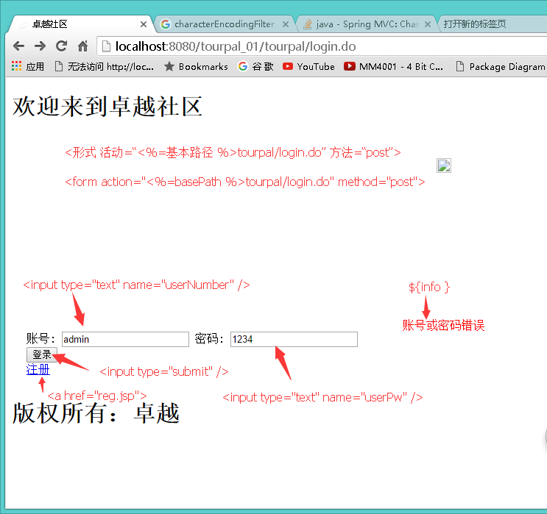

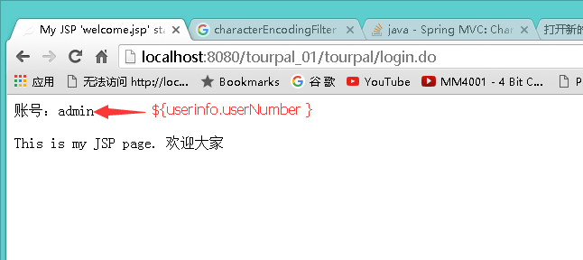

**警告：**

